
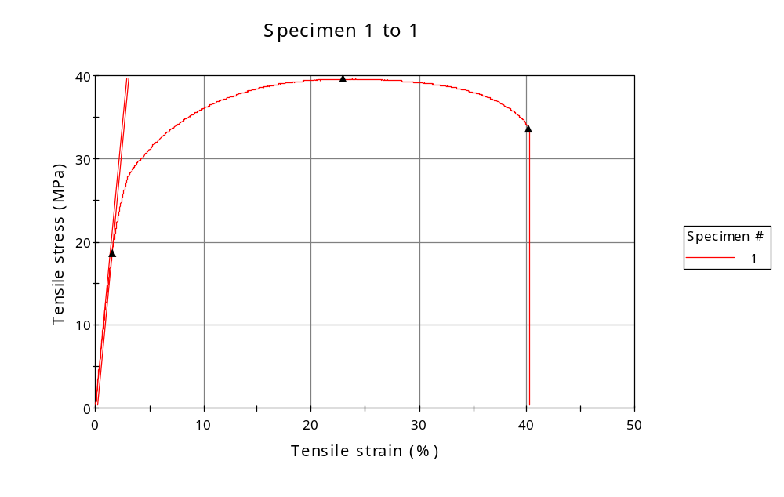
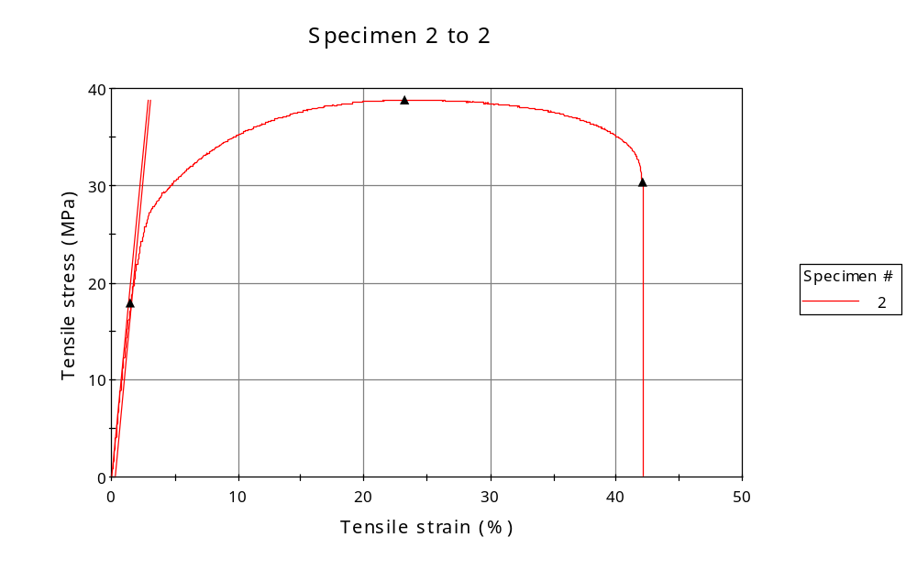
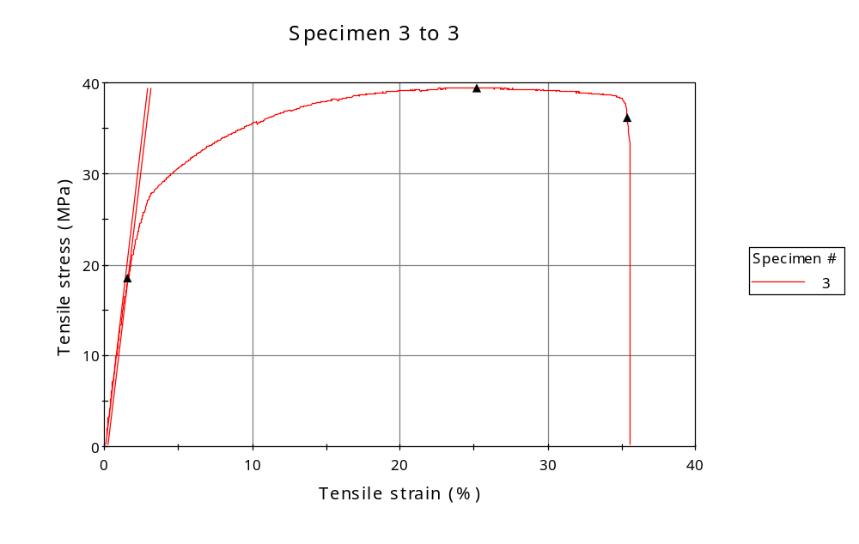
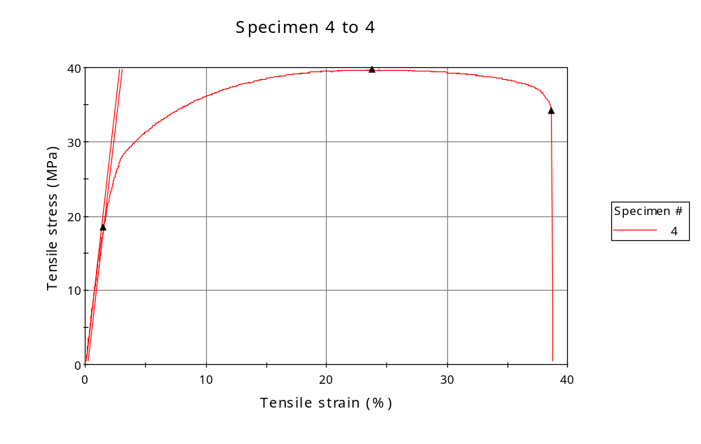
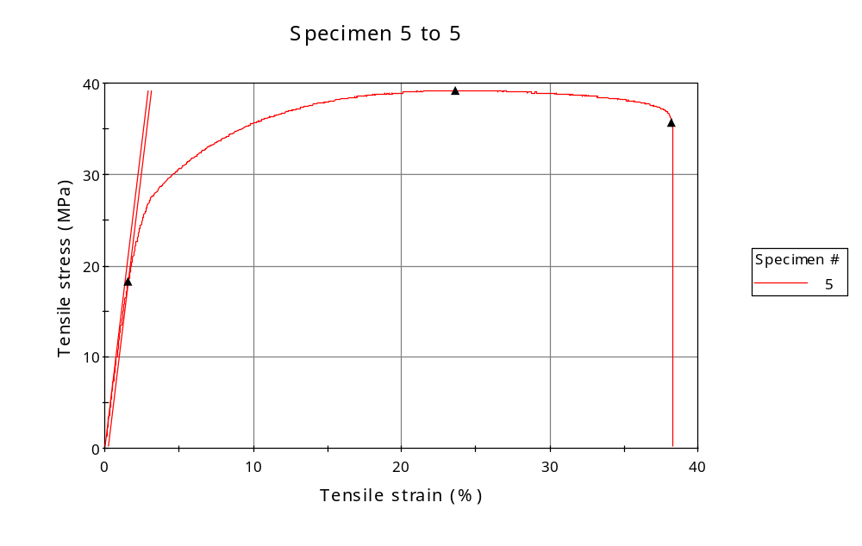
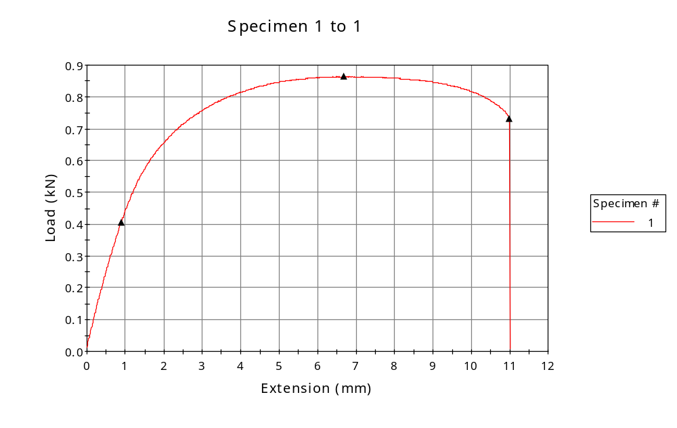
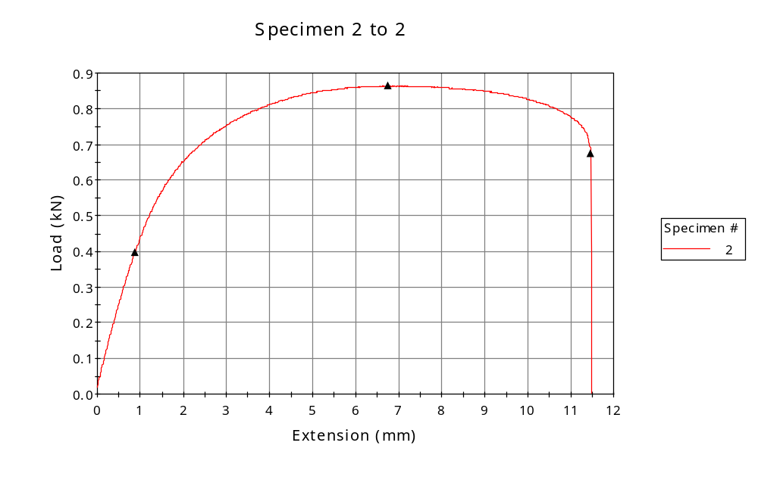
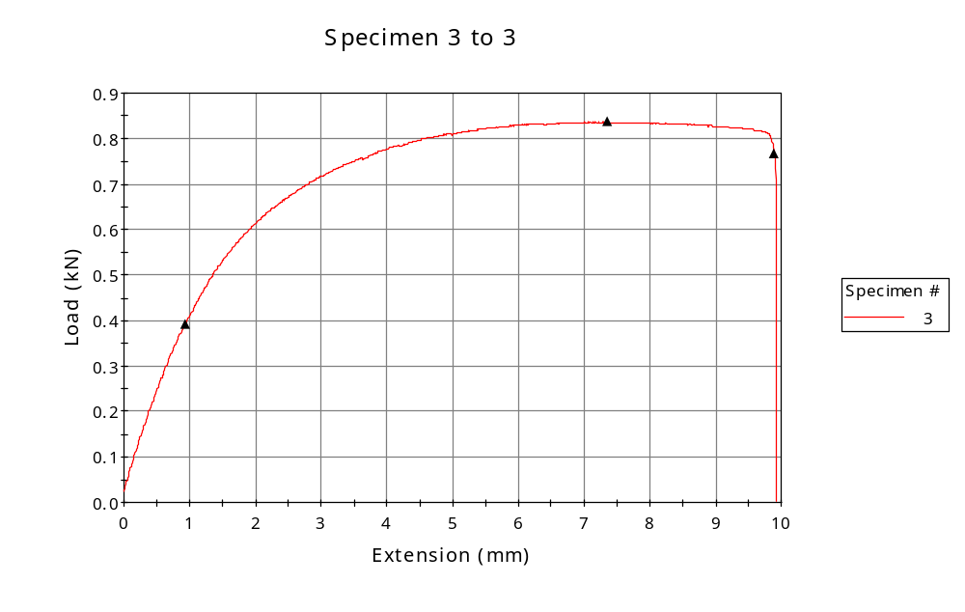
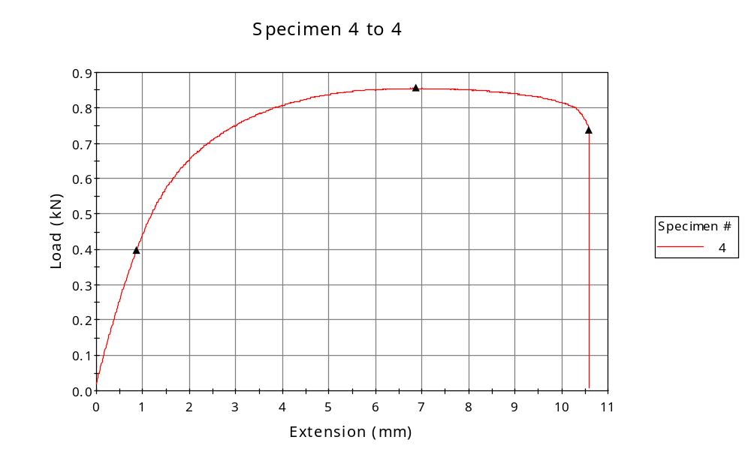
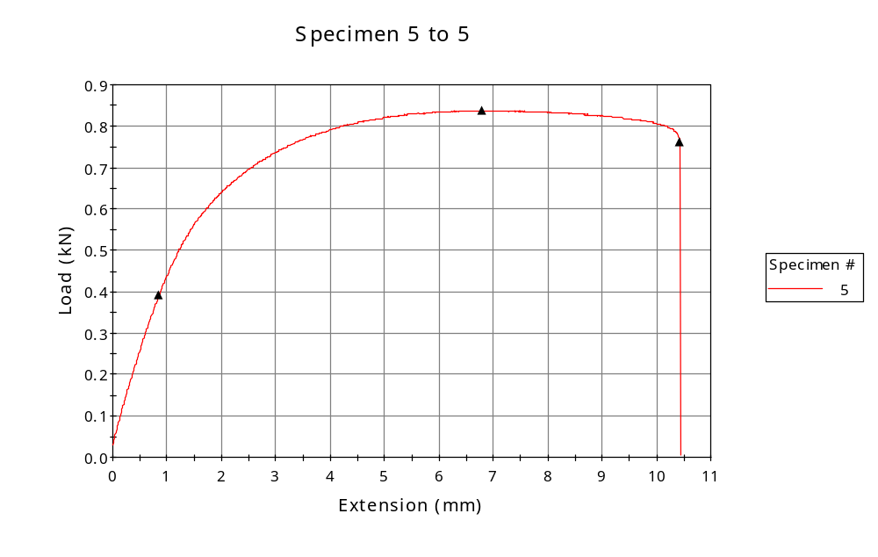

 | CP ID | Length  (mm) | Width  (mm) | Thickness  (mm) | Modulus (Automatic Young's)  (MPa)
1 | CP-SLS_XY1_01 | 25.00 | 6.42 | 3.40 | 1378
2 | CP-SLS_XY1_02 | 25.00 | 6.47 | 3.44 | 1383
3 | CP-SLS_XY1_03 | 25.00 | 6.26 | 3.39 | 1362
4 | CP-SLS_XY1_04 | 25.00 | 6.28 | 3.43 | 1412
5 | CP-SLS_XY1_05 | 25.00 | 6.25 | 3.42 | 1351
Maximum |  | 25.00 | 6.47 | 3.44 | 1412
Minimum |  | 25.00 | 6.25 | 3.39 | 1351

 | Load at Fy ( 0.2 %) - LE  (kN) | Tensao em Fy ( 0.2 %) - LE  (MPa) | Deformacao em Fy ( 0.2 %) - LE  (%) | Forca Max  (kN) | Tensao na Forca Max - LR  (MPa)
1 | 0.405 | 19 | 1.536 | 0.864 | 40
2 | 0.397 | 18 | 1.521 | 0.864 | 39
3 | 0.392 | 18 | 1.585 | 0.836 | 39
4 | 0.397 | 18 | 1.515 | 0.855 | 40
5 | 0.391 | 18 | 1.569 | 0.838 | 39
Maximum | 0.405 | 19 | 1.585 | 0.864 | 40
Minimum | 0.391 | 18 | 1.515 | 0.836 | 39

 | Deformacao na Forca Max - LR  (%) | Forca na Forca na Quebra - LQ  (kN) | Deformacao na Forca na Quebra - LQ  (%) | Final length  (mm) | Final width  (mm)
1 | 22.976 | 0.733 | 40.176 | 119.00 | 6.82
2 | 23.239 | 0.675 | 42.073 | 119.00 | 6.82
3 | 25.215 | 0.766 | 35.382 | 119.00 | 6.82
4 | 23.809 | 0.738 | 38.676 | 119.00 | 6.82
5 | 23.670 | 0.763 | 38.237 | 119.00 | 6.82
Maximum | 25.215 | 0.766 | 42.073 | 119.00 | 6.82
Minimum | 22.976 | 0.675 | 35.382 | 119.00 | 6.82

 | Alongamento
1 | 3.76
2 | 3.76
3 | 3.76
4 | 3.76
5 | 3.76
Maximum | 3.76
Minimum | 3.76

